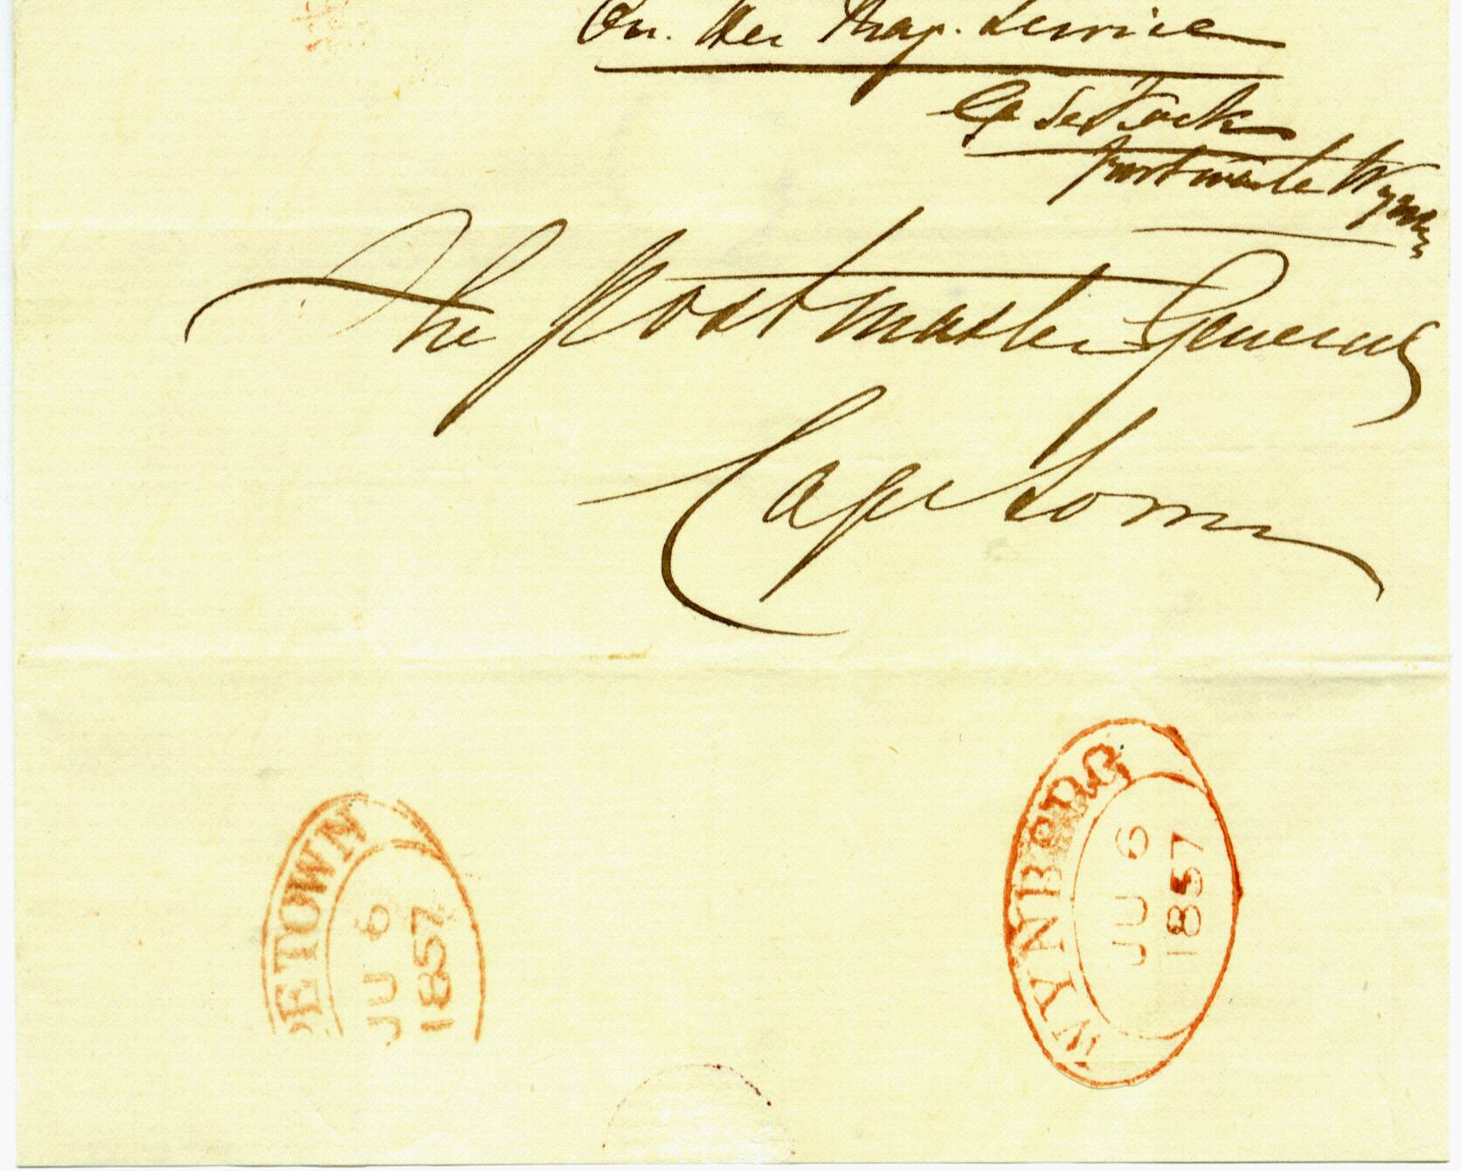
+

EARLIEST RECORDED EXAMPLE¹

WYNBERG DATED TOWN OVAL HANDSTAMP

1857 on H M Service outer letter sheet, from the Wynberg post office with bottom backflap opened out, showing a superb red strike of the “Wynberg D.T.O.” of 6th July 1857. The outer letter sheet is signed on front by the Postmaster of Wynberg. The backflap is struck with a superb red impression of the Cape Town receiving D.T.O of same date. Unique outer letter sheet, recording G de Tuck as Postmaster of Wynberg at the time.
Earliest recorded copy by Goldblatt is 14th April 1858

CAPE OF GOOD HOPE

DEVELOPENT OF POSTAL SERVICES

The Dated Town Oval

Handstamps of 1853

